Name:_______________
Classification Study Guide Date:_________ Per:___

Use the dichotomous key for North American Trees to identify the plants that the leaves pictured below came from. Record your answers next to each leaf.
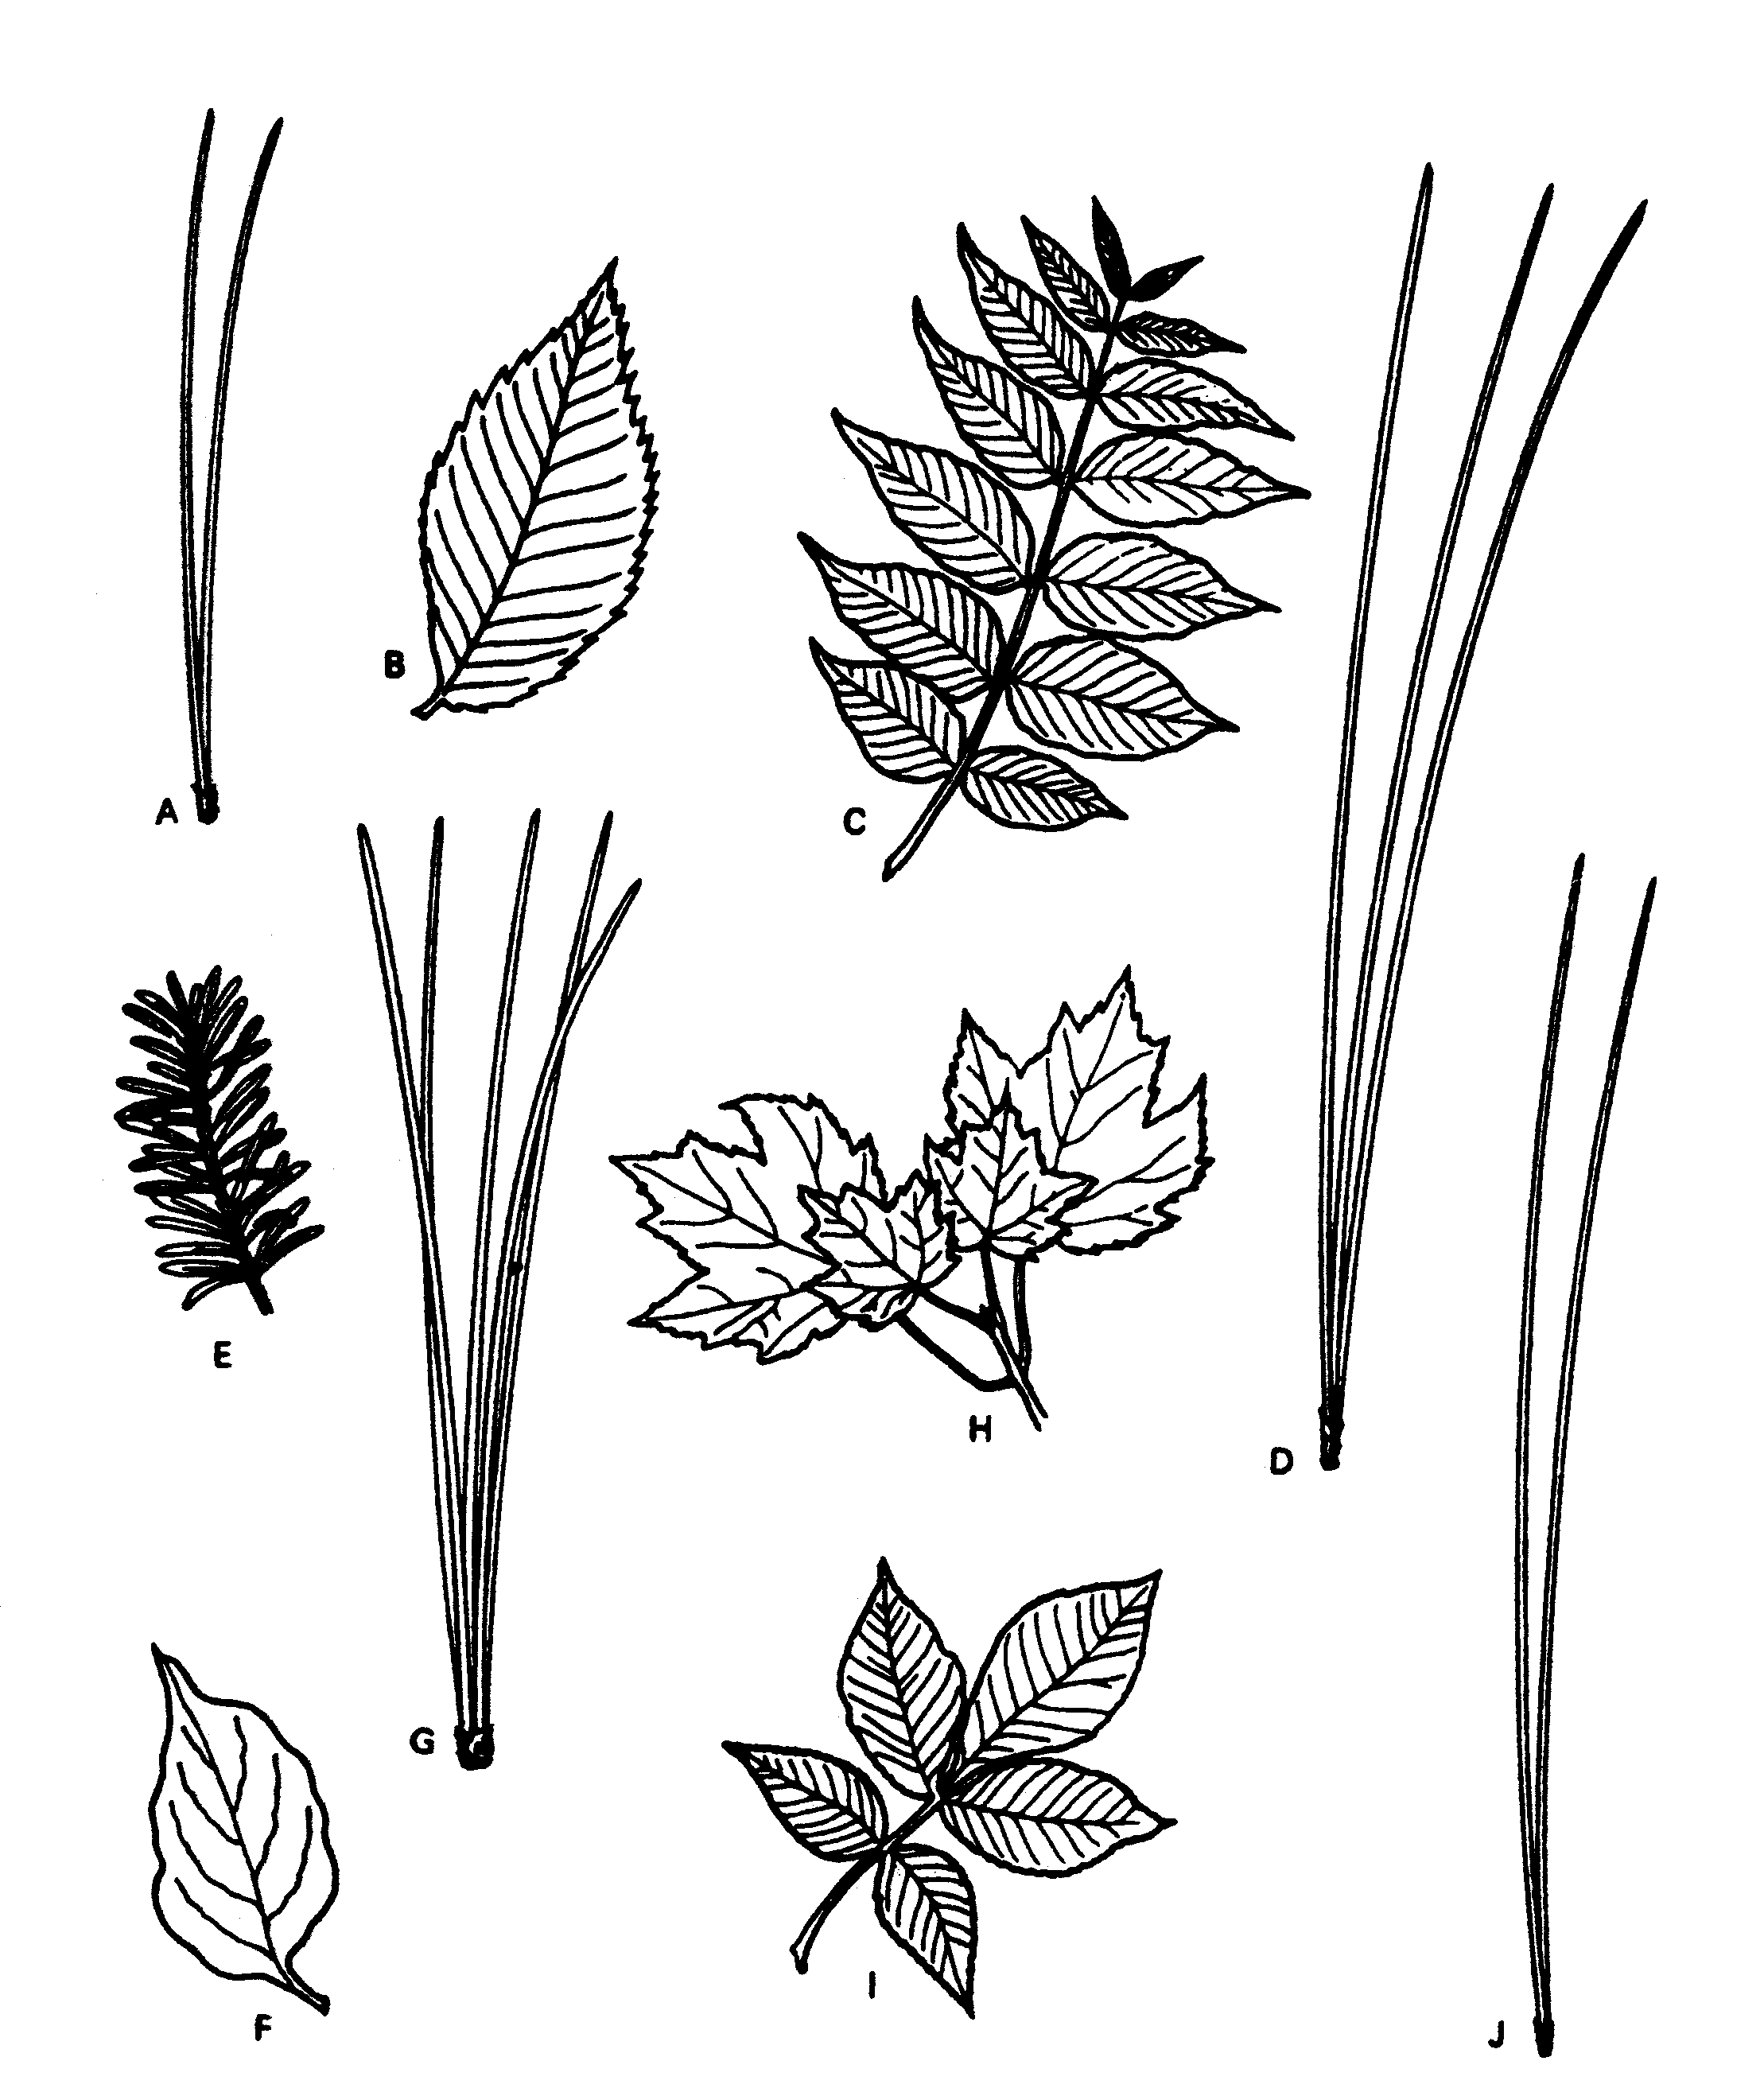

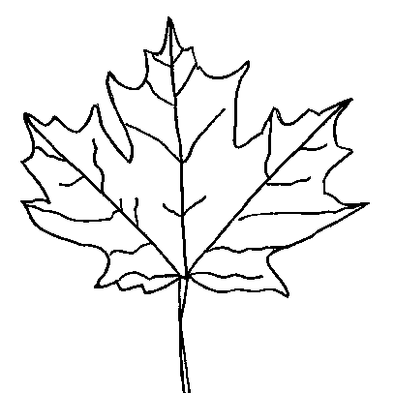

1) Who devised the modern classification and naming system (taxonomy and binomial nomenclature)?

  - What are the rules that apply to binomial nomenclature (what terms are used, how is it written)?

  - Provide an example of a name using binomial nomenclature

  - Describe the difference between a scientific name and a common name (how they are used, etc)
2) What are the 8 taxonomic levels that are used today?
3) What are the 3 domains of life?

4) In what kingdom do eukaryotes fall into? In what kingdom do prokaryotes fall into?

5) What are 4 defining characteristics of organisms classified as animals?
- Why are corals considered animals?

6) What are 4 defining characteristics of organisms classified as plants?

7) What are 4 defining characteristics of organisms classified as protists?

8) What are 4 defining characteristics of organisms classified as fungi?
- How do fungi resemble plants?

9) What are 4 defining characteristics of organisms classified as bacteria?

10) What are 4 defining characteristics of organisms classified as archaea?

11) Beside the name, how do we know if two organisms belong to two different species?

12) What is cladistics? What is a cladogram?
 |  | Animal Species
 |  | Humans | Crocodiles | Birds | Bats | Insects
Traits | Feathers |  |  | X
Traits | Hair | X |  |  | X
Traits | Epidermal Scales |  | X | X
Traits | Large Brain | X
Traits | Bones | X | X | X | X
Traits | Eukarotic Cells | X | X | X | X | X
- What are the parts of a cladogram?

13) Make a cladogram from the following data:

Dichotomous Key to North American Trees
1. A. Leaves thin and needle like Go to 2
B. Leaves broad with flattened blade Go to 6
2. A. Needles up to 2.5 cm long Yew
B. Needles 5 cm or longer Go to 3
3. A. Needles 5 to 10 cm long Go to 4
B. Needles more than 10 cm long Go to 5
4. A. Needles in clusters of two Scotch pine
B. Needles in clusters of four or five White pine
5. A. Needles in clusters of two Black pine
B. Needles in clusters of three Ponderosa pine
6. A. Leaves divided into separate leaflets Go to 7
B. Leaves in one piece, no leaflets Go to 8
7. A. Leaves with five to seven leaflets;
bottom pair smallest Shag bark hickory
B. Leaves with thirteen to forty-one
leaflets: edges of leaflets with one
or two coarse teeth Tree of heaven
8. A. Leaf edge smooth, lacking saw-
teeth or lobes Flowering dogwood
B. Leaf edge saw-toothed, wavy or lobed Go to 9
9. A. Leaves saw-toothed; veins like barbs
on a feather Beech
B. Leaves three to five lobes; veins
radiating from a central point Sugar maple

Dichotomous Key to North American Trees
1. A. Leaves thin and needle like Go to 2
B. Leaves broad with flattened blade Go to 6
2. A. Needles up to 2.5 cm long Yew
B. Needles 5 cm or longer Go to 3
3. A. Needles 5 to 10 cm long Go to 4
B. Needles more than 10 cm long Go to 5
4. A. Needles in clusters of two Scotch pine
B. Needles in clusters of four or five White pine
5. A. Needles in clusters of two Black pine
B. Needles in clusters of three Ponderosa pine
6. A. Leaves divided into separate leaflets Go to 7
B. Leaves in one piece, no leaflets Go to 8
7. A. Leaves with five to seven leaflets;
bottom pair smallest Shag bark hickory
B. Leaves with thirteen to forty-one
leaflets: edges of leaflets with one
or two coarse teeth Tree of heaven
8. A. Leaf edge smooth, lacking saw-
teeth or lobes Flowering dogwood
B. Leaf edge saw-toothed, wavy or lobed Go to 9
9. A. Leaves saw-toothed; veins like barbs
on a feather Beech
B. Leaves three to five lobes; veins
radiating from a central point Sugar maple

Dichotomous Key to North American Trees
1. A. Leaves thin and needle like Go to 2
B. Leaves broad with flattened blade Go to 6
2. A. Needles up to 2.5 cm long Yew
B. Needles 5 cm or longer Go to 3
3. A. Needles 5 to 10 cm long Go to 4
B. Needles more than 10 cm long Go to 5
4. A. Needles in clusters of two Scotch pine
B. Needles in clusters of four or five White pine
5. A. Needles in clusters of two Black pine
B. Needles in clusters of three Ponderosa pine
6. A. Leaves divided into separate leaflets Go to 7
B. Leaves in one piece, no leaflets Go to 8
7. A. Leaves with five to seven leaflets;
bottom pair smallest Shag bark hickory
B. Leaves with thirteen to forty-one
leaflets: edges of leaflets with one
or two coarse teeth Tree of heaven
8. A. Leaf edge smooth, lacking saw-
teeth or lobes Flowering dogwood
B. Leaf edge saw-toothed, wavy or lobed Go to 9
9. A. Leaves saw-toothed; veins like barbs
on a feather Beech
B. Leaves three to five lobes; veins
radiating from a central point Sugar maple

Dichotomous Key to North American Trees
1. A. Leaves thin and needle like Go to 2
B. Leaves broad with flattened blade Go to 6
2. A. Needles up to 2.5 cm long Yew
B. Needles 5 cm or longer Go to 3
3. A. Needles 5 to 10 cm long Go to 4
B. Needles more than 10 cm long Go to 5
4. A. Needles in clusters of two Scotch pine
B. Needles in clusters of four or five White pine
5. A. Needles in clusters of two Black pine
B. Needles in clusters of three Ponderosa pine
6. A. Leaves divided into separate leaflets Go to 7
B. Leaves in one piece, no leaflets Go to 8
7. A. Leaves with five to seven leaflets;
bottom pair smallest Shag bark hickory
B. Leaves with thirteen to forty-one
leaflets: edges of leaflets with one
or two coarse teeth Tree of heaven
8. A. Leaf edge smooth, lacking saw-
teeth or lobes Flowering dogwood
B. Leaf edge saw-toothed, wavy or lobed Go to 9
9. A. Leaves saw-toothed; veins like barbs
on a feather Beech
B. Leaves three to five lobes; veins
radiating from a central point Sugar maple

